NETWORKING & SYSTEM ADMINISTRATION LAB

Experiment No.: 9

Aim:
Write a program shell scripting to print the basic details.

Procedure
- vi sample.sh –open a shell script file in the terminal
- chmod +x sample.sh – to give the permission to read the file.
3./sample.sh – to excute the program also print the output.
4.bash sample.sh - to excute the program .And print the output.

OUTPUT:
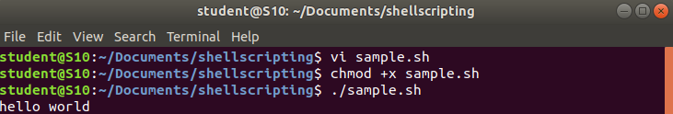
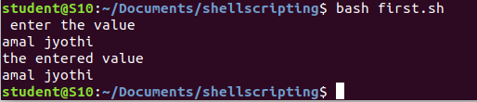

Experiment No.: 10

Aim:
Write a program shell scripting to print sum of two numbers.

Procedure :
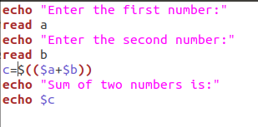

output:
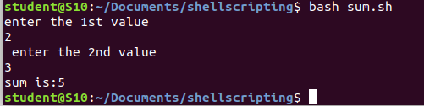

Experiment No.: 11

Aim:
Write a program shell scripting to find the largest of two numbers.

Procedure :
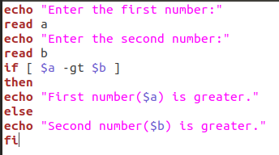

output:
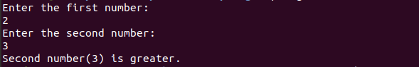

Experiment No.: 12

Aim:
Write a program shell scripting to find whether a number is even or odd.

Procedure :
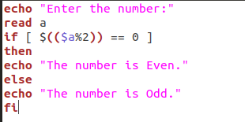

output
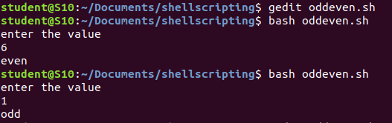

Experiment No.: 13

Aim:
Write a program shell scripting to find largest of three numbers.

Procedure:

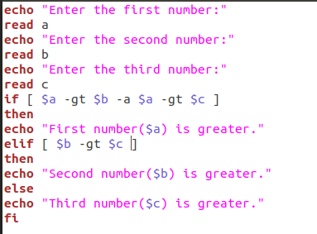

Output:
